Stage 6 – ...we would've been state champions.
COURSE DESIGNER: Ike Starnes
SCORING: Comstock 24 rounds.
TARGETS: 10 cardboard targets, 4 steel targets
SCORED HITS: 2 Best hits per carboard will be scored.

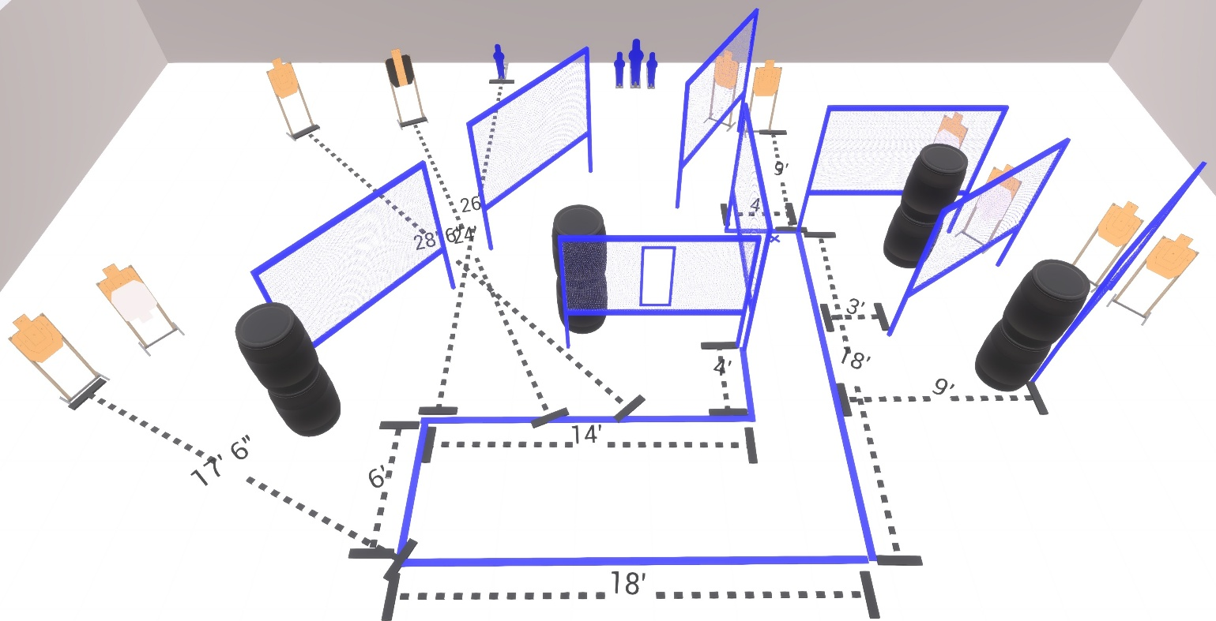

Written Stage Briefing:

Stage 6 – ...we would've been state champions. - is a 24 round, 140 point, Comstock Course. There are 10 cardboard targets and 4 steel targets

Starting with both feet on the Shooting Sports Innovations Xs.
Handgun is loaded and holstered, wrists below belt.
PCC is loaded held in both hands, stock on belt.

On the audible start signal, engage targets from within the shooting area.

USPSA / NROI Range Commands:
- Make Ready
- Are you ready?
- Standby
- If finished, unload and show clear
- If clear, hammer down and holster (Handgun)
If clear, hammer down and flag (PCC)
If clear, cylinder closed and holster (Revolver)
- Range is clear

Setup Notes:
14 Single Wall Stands
1 Double Wall Stands
7 Full Walls
1 Port Wall
10 Target stands / 20 target sticks
2 Large Poppers + bases
2 Small Poppers + bases
1 Starting Xs
8+ Barrels

